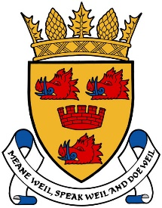

CROMARTY & DISTRICT COMMUNITY COUNCIL

NEEDS YOU
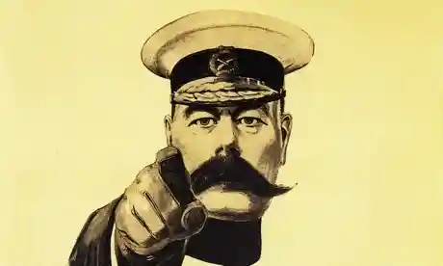

“Following an assessment of the nominations received for Community Council elections, Highland Council have agreed to extend the nomination period by 3 weeks to 12 noon on the 29 October. Election day will now be the 4 December rather than the 21 November. They want to try and encourage as many individuals to stand for Community Councils as possible and to ensure that most Community Councils re-form. They feel that it is important to allow this extension to give people more time to come forward. Highland Council will combine this extension with additional publicity to try and raise awareness of the elections and encourage more people to stand.”

On this occasion, we had very few nominations.
There are 7 positions on the CC and failure to fill these posts will result in the CC being limited to the amount of support they can give the community. We/you need more nominations.

Failure to have at least 4 nominations would lead to the disbanding of C&DCC.

Nomination forms and copies of the scheme for the establishment of community councils can be:
- Downloaded from The Highland Council web site at:
www.highland.gov.uk/elections
- Obtained by request, by email to:
election@highland.gov.uk ; or
- From the Council`s Service Centre, phone: 01349 886606

